**HAZARD MAPPING** - COMPUTER VISION BASED APPROACH USING PYTHON AND QGIS AND OPENCV

Workflow:

1. Load raster and Extract Region of Interest (ROI)
   1. Python-opencv and rasterio was used to read tmc data exported as .tif file from qgis after cropping ROI in qgis using raster-extract tool.
   2. A slope map or same ROI was extracted from qgis in .tif format by using the raster terrain analysis tool “Slope”. This was read in using rasterio. (z-factor was set to 20.00 to extract only high slope areas)
   3. The read data was reshaped to (x, y, bands) shape and stored as numpy arrays.

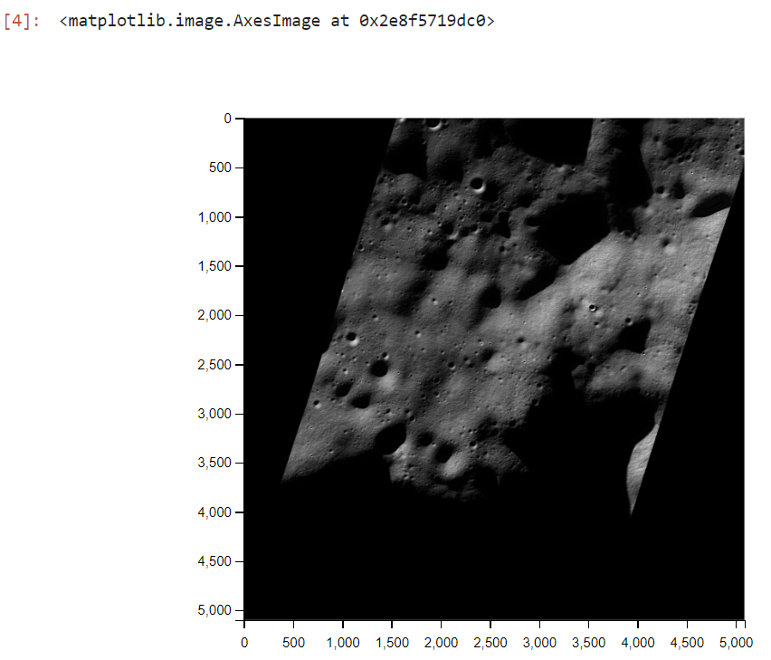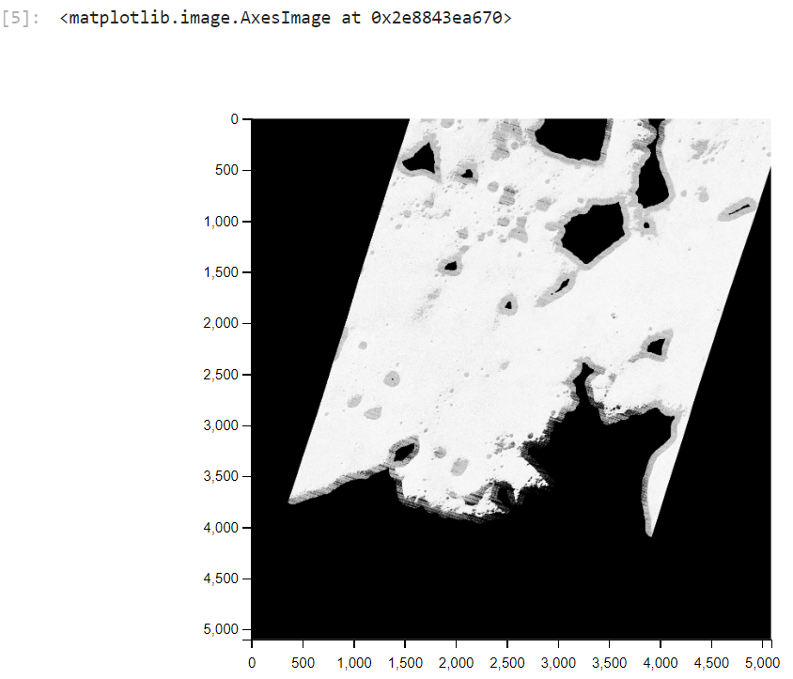

1. Identify High Slope areas
2. Slope map was converted to gray scale and high slope gradient was figured out by identifying values in the np array in the high slope gradient range using cv2.inRange() function
3. A mask was created using the above function and placed on the tmc roi data to identify high slope regions.

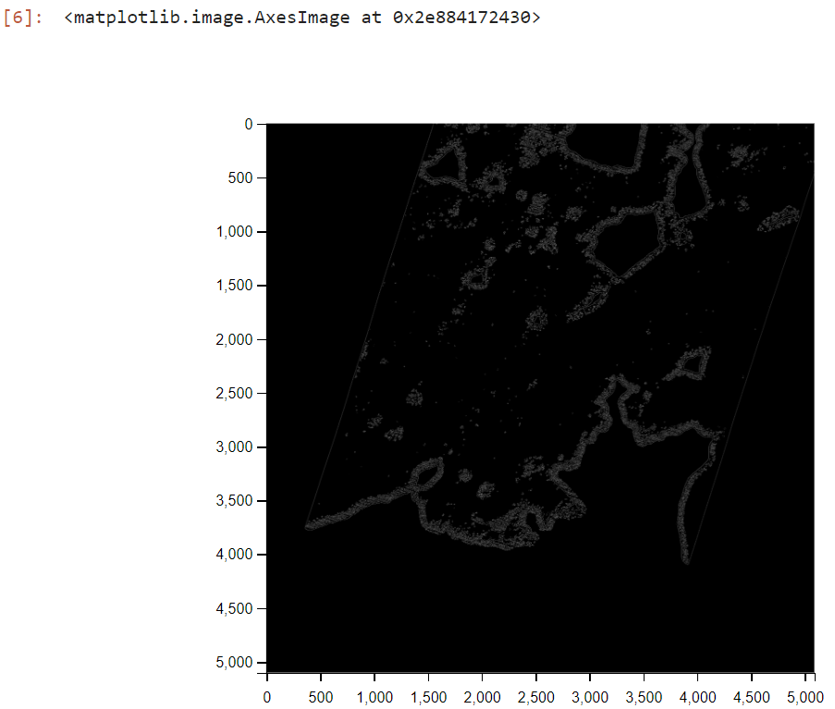

1. Ridge Detection with Canny Edge

1. A copy of the initial roi was extensively blurred using the gaussian blur method for identification of high risk ridges
2. Opencv Canny Edge algorithm was executed on the blurred image to create a mask of edges found of high risk grayscale gradient. The higher the gradient, the faster neighboring pixels change grayscale values. This mask was superimposed on the tmc roi np array to identify ridges too risky for a rover to cross.
3. The steepness of the ridge was identified by the grayscale intensity of the canny edge mask lines

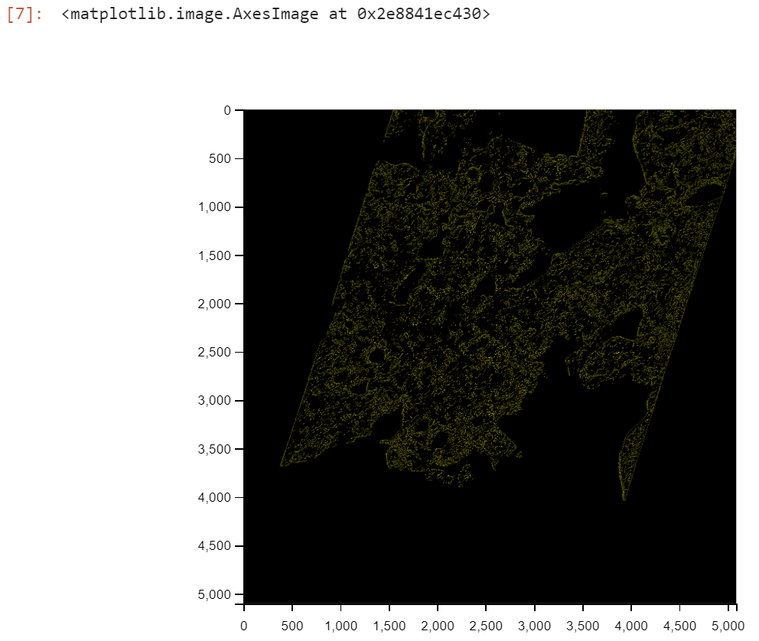

1. Crater Filtering with Hough-Circles Algorithm
2. Original tmc roi was converted to grayscale and blurred.
3. Hough Circles algorithm was fine tuned to identify different craters fitting two category sizes.
4. Both these categories had their own hough circle filter to identify individual craters and dense small-sized crater areas to avoid.

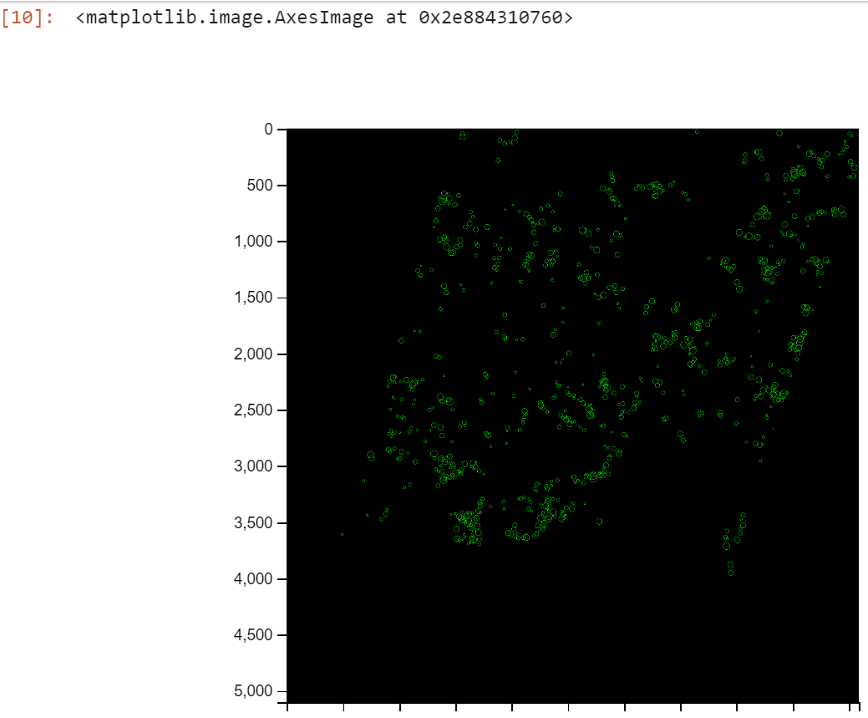

All Layers of Hazards Mapped and superimposed on original tmc roi image

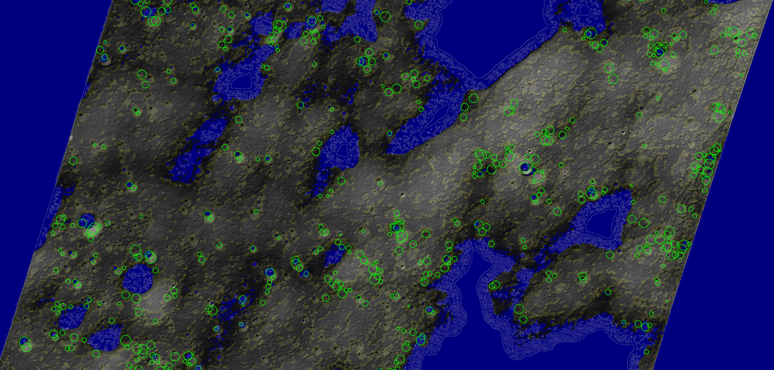

**Hyperspectral Analysis** of CH2 **IIRS Data** to Identify **Regions of Scientific Interest** (High **Mineral Diversity** and **Concentration**) to Designate as **Stop Points** for Rover Path using Spectral Python

Reference:

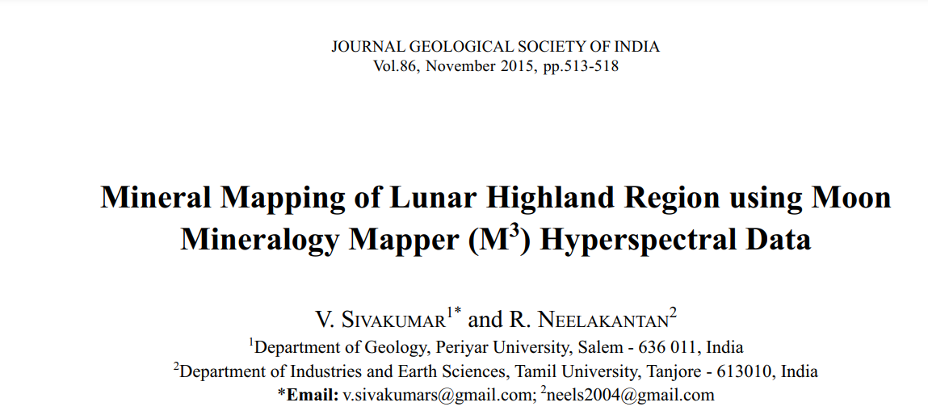

Workflow:

1. MNF (Maximum Noise Fraction) method applied to reduce dimensionality of original image.
2. Calculated Noise Covariant Matrix (say cov1)
3. Calculated inverse of cov1
4. Performed Noise whitening
5. Applied PCA to whitened data
6. Sorted eigenvectors in descending order
7. Transformed whitened data using sorted eigenvectors

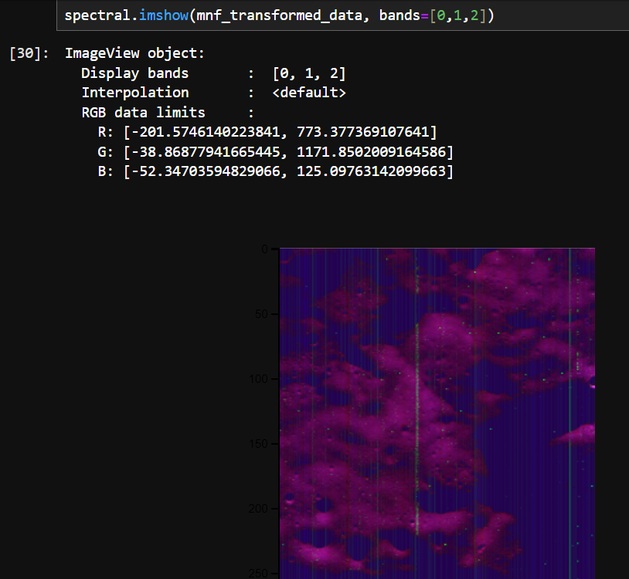

1. Calculated PPI (Pixel Purity Index) to identify endmembers, extracted using K-Means. 7 endmembers were processed

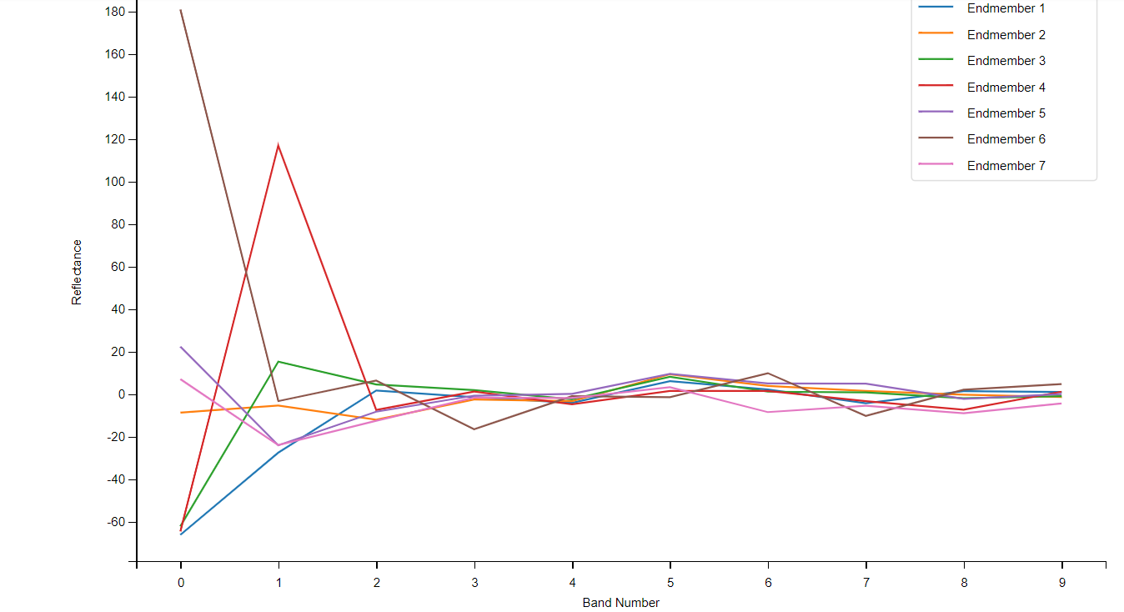

1. MSAM, a modified version of the SAM (Spectral Angle Mapper) algorithm was used to identify spatial distribution of the endmembers on the region of interest. The endmembers extracted from PPI by K-Means was used as reference spectra for the MSAM method.

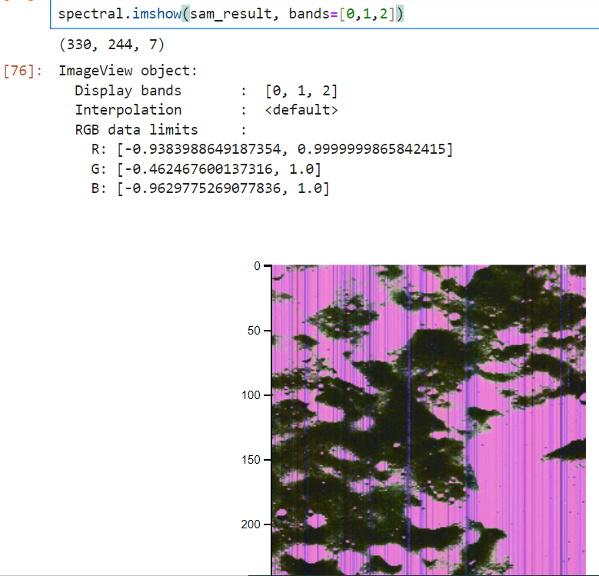

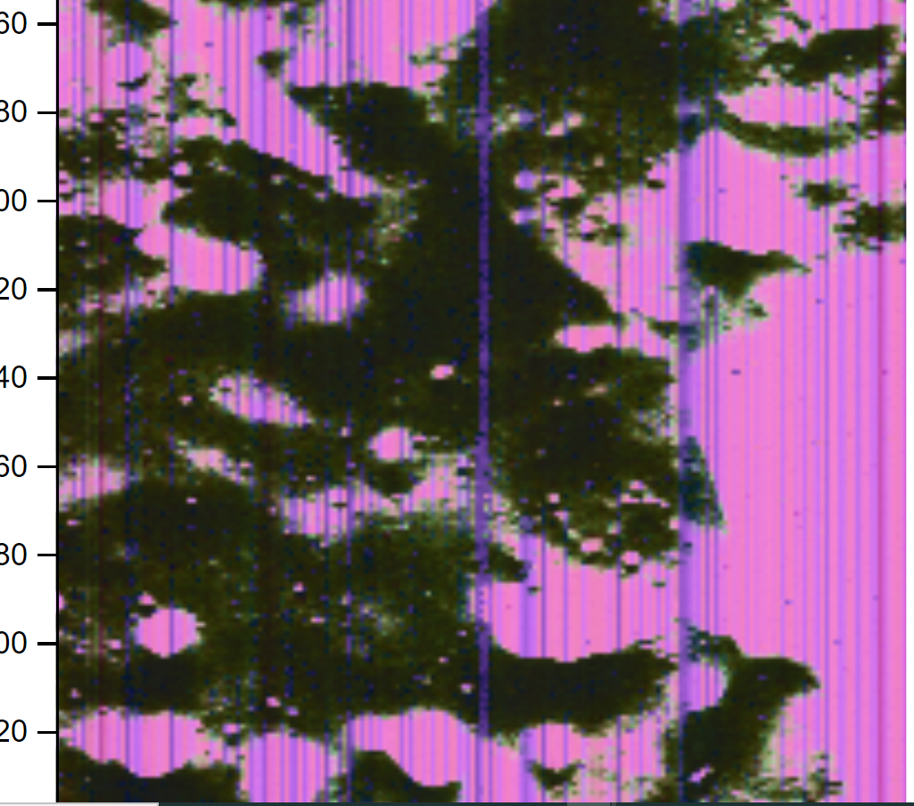

Non Black and Pink regions highlighted by green clusters are the most diverse and concentrated groups of minerals like olivine, anorthosite, pyroxene etc.